Huawei FusionDirector For vROps Plug-in
1.0
 | User Guide
 | Issue | 01
 | Date | 2019-05-15

 | HUAWEI TECHNOLOGIES CO., LTD. |  | 

Copyright © Huawei Technologies Co., Ltd. 2019. All rights reserved.
No part of this document may be reproduced or transmitted in any form or by any means without prior written consent of Huawei Technologies Co., Ltd.

Trademarks and Permissions
and other Huawei trademarks are trademarks of Huawei Technologies Co., Ltd.
All other trademarks and trade names mentioned in this document are the property of their respective holders.

Notice
The purchased products, services and features are stipulated by the contract made between Huawei and the customer. All or part of the products, services and features described in this document may not be within the purchase scope or the usage scope. Unless otherwise specified in the contract, all statements, information, and recommendations in this document are provided "AS IS" without warranties, guarantees or representations of any kind, either express or implied.
The information in this document is subject to change without notice. Every effort has been made in the preparation of this document to ensure accuracy of the contents, but all statements, information, and recommendations in this document do not constitute a warranty of any kind, express or implied.

Huawei Technologies Co., Ltd.
Address: | Huawei Industrial Base  Bantian, Longgang  Shenzhen 518129  People's Republic of China
Website: | http://www.huawei.com
Email: | support@huawei.com

About this Document
Overview
This guide describes how to install and maintain Huawei vRealize Operations Manager (vROps) plug-in.
Intended Audience
This guide is intended for:
- Technical support engineers
- System maintenance engineers
Symbol Conventions
The symbols that may be found in this document are defined as follows.
Symbol | Description
 | Indicates an imminently hazardous situation which, if not avoided, will result in death or serious injury.
 | Indicates a potentially hazardous situation which, if not avoided, could result in death or serious injury.
 | Indicates a potentially hazardous situation which, if not avoided, may result in minor or moderate injury.
 | Indicates a potentially hazardous situation which, if not avoided, could result in equipment damage, data loss, performance deterioration, or unanticipated results.  NOTICE is used to address practices not related to personal injury.
Calls attention to important information, best practices, and tips.
NOTE is used to address information not related to personal injury, equipment damage, and environment deterioration.

Change History
Changes between document issues are cumulative. The latest document issue contains all the changes made in earlier issues.
Issue | Date | Description
01 | 2019-05-15 | The issue is the first official release.

Contents
About this Document ii
1 Overview 1
2 Managing the vROps Plug-in 2
2.1 Installation 2
2.2 Uninstallation 5
2.3 Upgrade 5
3 Setting the FusionDirector 6
3.1 Addition 6
3.2 Modification 16
3.3 Deletion 18
4 Querying Server Information 20
4.1 Querying Servers 20
4.2 Querying Component Information 22
4.3 Querying Component Group Information 24
4.4 Querying Server Information 25
4.5 Querying Server Type Information 26
4.6 Querying the FusionDirector Information 27
5 Querying Enclosure Information 29
5.1 Querying Enclosures 29
5.2 Querying Component Information 30
5.3 Querying Component Group Information 32
5.4 Querying Enclosure Information 33
5.5 Querying the FusionDirector Information 34
6 Querying Dashboard Information 36
6.1 Querying the FusionDirector Overview Dashboard 36
6.2 Querying Huawei Servers Overview Dashboard 36
6.3 Querying Huawei Server Detailed Dashboard 40
6.4 Querying Huawei Enclosure Overview Dashboard 41
6.5 Querying Huawei Enclosure Detailed Dashboard 42
7 Viewing Alerts 44
8 Querying the Huawei vROps Plug-in Version 47

Overview
Huawei FusionDirector for vRealize Operations Manager (vROps) plug-in can be used to manage and monitor Huawei servers. The vROps UI varies according to its version. This document uses the vROps 6.7 as an example.
Huawei FusionDirector for vROps plug-in provides the following functions:
- Query the basic information about severs and enclosures (also referred to as chassis).
- Query the alert information about severs and enclosures.
- Query the health status of severs and enclosures.
- Query statistics about the FusionDirector, severs, and enclosures using the dashboard.
- Table 1-1 lists servers supported by Huawei FusionDirector for vROps plug-in.
                - Supported servers
Type | Server
Rack | 1288H V5
Rack | 2288H V5
Rack | 2488 V5
Rack | 2488H V5
Rack | 8100 V5
Rack | RH2288H V3
Blade | CH121 V5
Blade | CH242 V5
Blade | CH121 V3
Blade | CH242 V3
Chassis | E9000 (MM920)

Managing the vROps Plug-in
2.1 Installation
2.2 Uninstallation
2.3 Upgrade

Installation
            - Access GitHub and download the latest vROps installation package, such as Huawei_FusionDirector_For_vROps_X.X.X.zip.
            - Decompress the installation package.
Obtain the installer, such as HuaweiFusionDirectorManagementPack_X.X.X.pak.
            - On the vROps WebUI, choose Administration.
The Administration page is displayed.
            - In the navigation pane, choose Solutions.
The Solutions page is displayed.
            - Click .
The Add Solution dialog box is displayed, as shown in Figure 1-1.
              - Selecting a solution
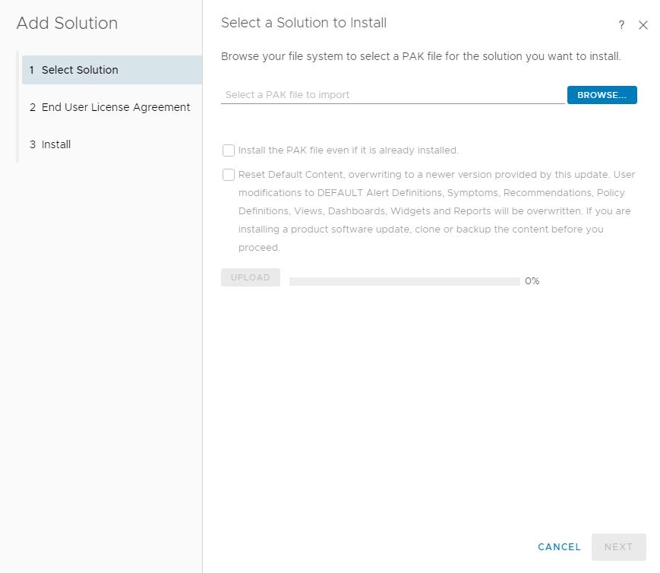

            - Click the Select Solution tab.
            - Click BROWSE and select the installation package.
            - (Optional) Select Install the PAK file even if it is already installed.
            - Click UPLOAD and upload the installation file.
            - Click NEXT.
The Confirmation dialog box is displayed.
            - Click Yes.
The End User License Agreement page is displayed, as shown in Figure 1-1.
              - End User License Agreement
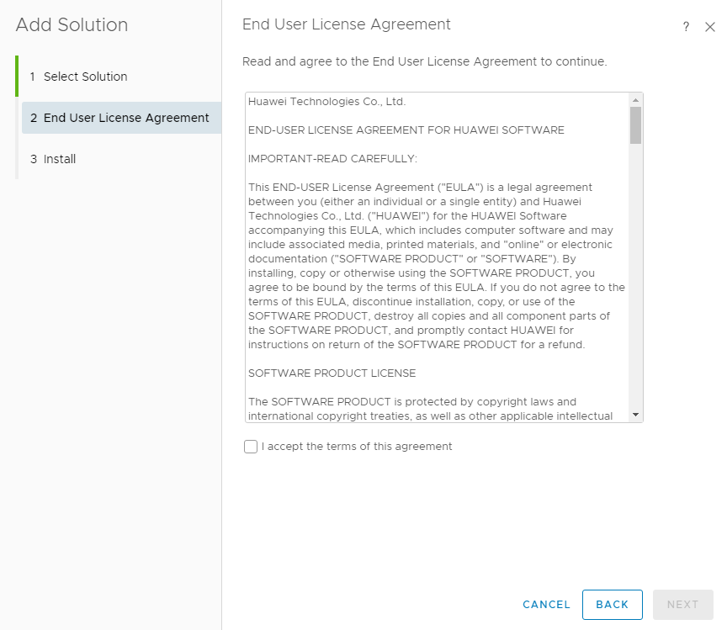

            - Select I accept the terms of this agreement and click NEXT.
The Installation page is displayed.
            - After the installation is complete, click FINISH.
Check the installed vROps on the Solutions page, as shown in Figure 1-1.
              - Viewing the vROps
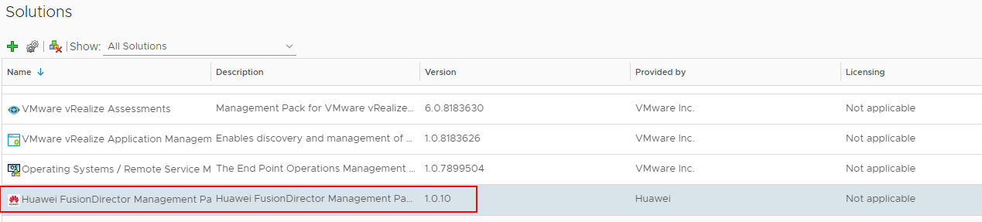

----End

Uninstallation
            - On the vROps WebUI, choose Administration.
The Administration page is displayed.
            - In the navigation pane, choose Solutions.
The Solutions page is displayed.
            - Select the vROps plug-in and click , as shown in Figure 1-1.
              - Uninstalling the vROps

The Alerts dialog box is displayed.
Only Huawei vROps 6.6 and later versions can be uninstalled.
            - Select I understand the risk and agree. and click OK.
Huawei vROps plug-in is uninstalled.
----End

Upgrade
Procedure
            - (Optional) Uninstall Huawei vROps plug-in of the early version. For details, see 2.2 Uninstallation.
            - Install Huawei vROps plug-in of the late version. For details, see 2.1 Installation.
----End

Setting the FusionDirector
3.1 Addition
3.2 Modification
3.3 Deletion

Addition
            - On the vROps WebUI, choose Administration.
The Administration page is displayed.
            - In the navigation pane, choose Solutions.
The Solutions page is displayed.
            - Select the vROps plug-in and click .
The Manage Solution - Huawei FusionDirector Management Pack dialog box is displayed.
            - In the Instance Settings area, set the following parameters, as shown in Figure 1-1.
              - Instance settings
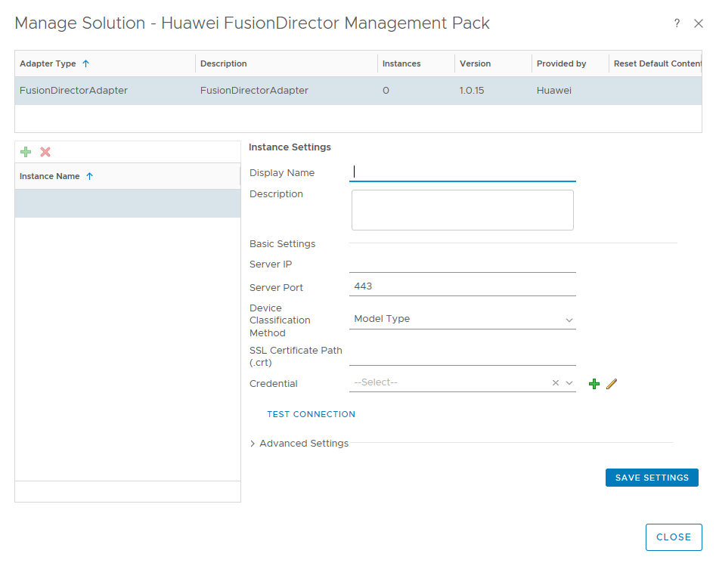

- Display Name: user-defined name to identify different FusionDirector instances
- Description: (optional) user-defined description to describe a FusionDirector instance
- Server IP: FusionDirector IP address
- Server Port: FusionDirector port number, which is 443 by default.
- Device Classification Method: way to classify servers
- Model Type: classify servers by type
- Group Type: classify servers by group
- SSL Certificate Path(.crt): (optional) path of the certificate in the vROps


You are advised to upload the SSL certificate for security. For details about how to upload the certificate, see Step 5 to Step 6.
            - (Optional) Obtain the certificate.
- Access the FusionDirector WebUI.
- Click Certificate error in the address box of the browser.
The Certificate Invalid dialog box is displayed, as shown in Figure 1-1.
              - Invalid certificate
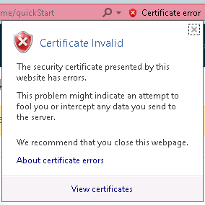

- Click View certificates.
The Certificate dialog box is displayed.
- Click the Details tab.
The Details tab is displayed, as shown in Figure 1-2.
              - Details
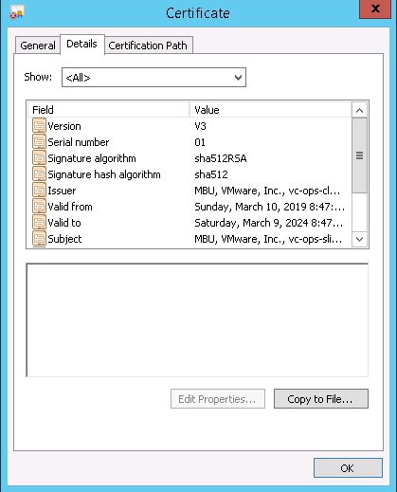

- Click Copy to File....
The Certificate Export Wizard is displayed, as shown in Figure 1-3.
              - Certificate Export Wizard
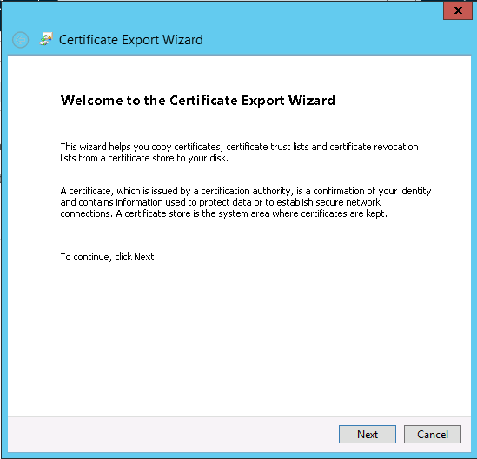

- Click Next. In the Certificate Export Wizard dialog box, select DER encoding binary X.509 (.CER), as shown in Figure 1-4.
              - Setting the format of files to be exported
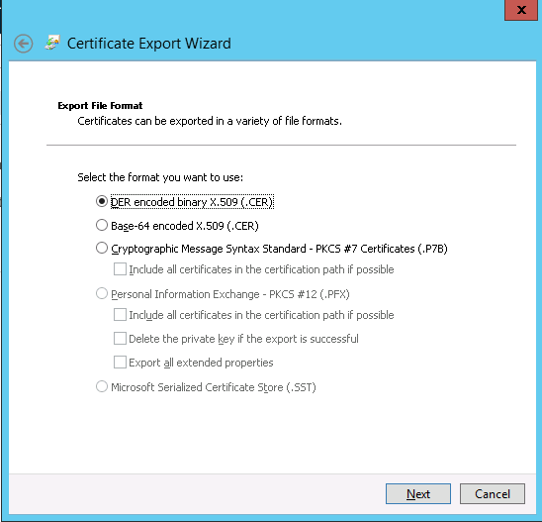

- Click Next. In the Certificate Export Wizard dialog box, click Browse..., select the certificate export path, and enter the certificate file name, as shown in Figure 1-5.
              - Service certificate
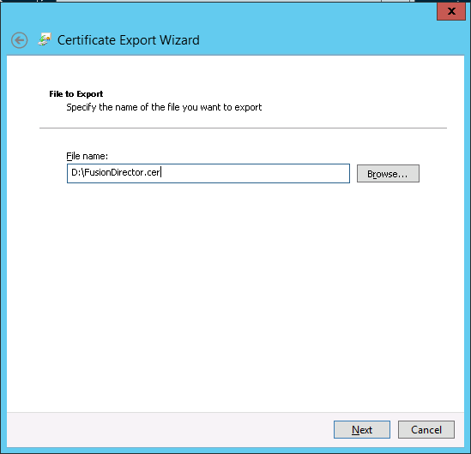

- Click Next to complete certificate export.
            - (Optional) Import the certificate file to the vROps backend.
- Configure the SSH access permission for the vROps.
  - The vROps backend is displayed, as shown in Figure 1-1.
              - vROps backend
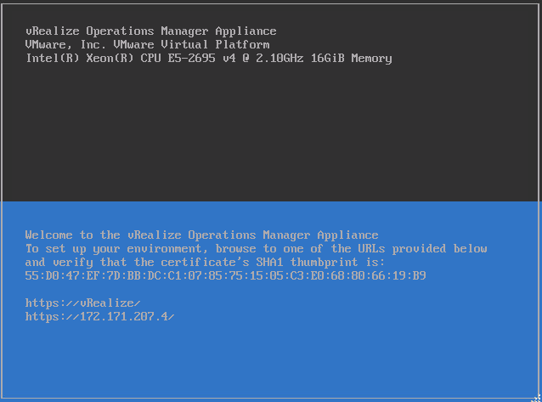

  - Press Alt+F1 and enter the username and password to log in to the vROps, as shown in Figure 1-2.
- The username is root and the initial password is blank.
- When you log in for the first time, you need to change the initial password, press Enter, enter previous and new passwords, and confirm the new password. The new password must contain uppercase letters, lowercase letters, digits, and special characters.
              - Logging in to the vROps
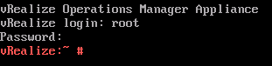

  - Run the vi /etc/ssh/sshd_config command to edit the configuration file sshd_config.
Change the value of MaxSession to 20 and the value of AllowTcpForwarding to yes.
  - Run the service sshd start command to start the SSHD service.
  - Run the chkconfig sshd on command to enable the SSHD service.
  - Run the service vmware-vcops-firewall stop command to disable the firewall.
  - Run the chkconfig vmware-vcops-firewall off command to disable the firewall upon startup.
- Use the SSH tool to upload the certificate file to /usr/lib/vmware-vcops/user/plugins/inbound.
- Enter the SSL certificate path /usr/lib/vmware-vcops/user/plugins/inbound/FusionDirector.crt in Step 4.
            - In the Credential field, click .
The Manage Credentials dialog box is displayed.
            - Set the following parameters and click OK, as shown in Figure 1-1.
              - Managing credentials
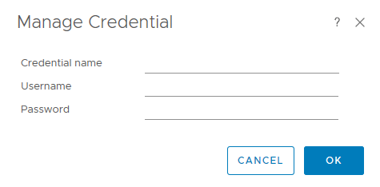

- Credential name: user-defined name to identify different credentials
- Username: FusionDirector username to access the Redfish API. The default username is rootRedfish.
- Password: FusionDirector password to access the Redfish API. The default password is Machine@123.
            - Click TEST CONNECTION.
If the test connection is successful, a dialog box is displayed, as shown in Figure 1-1. Click OK. If the test connection fails, the failure cause is displayed. Modify the FusionDirector information as prompted.
              - Successful test connection
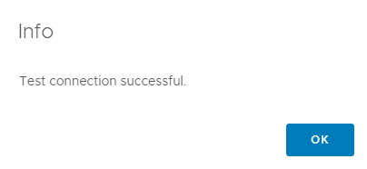

            - Click SAVE SETTINGS.
The dialog box is displayed indicating that the settings are successfully saved, as shown in Figure 1-1.
              - Successfully saving settings
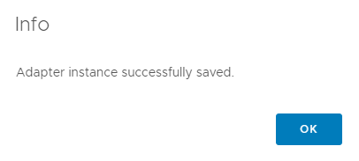

            - Click OK.
The FusionDirector instance is added.
            - Click CLOSE.
On the Solutions page, view the data collected by the FusionDirector instance, as shown in Figure 1-1.
              - Solutions
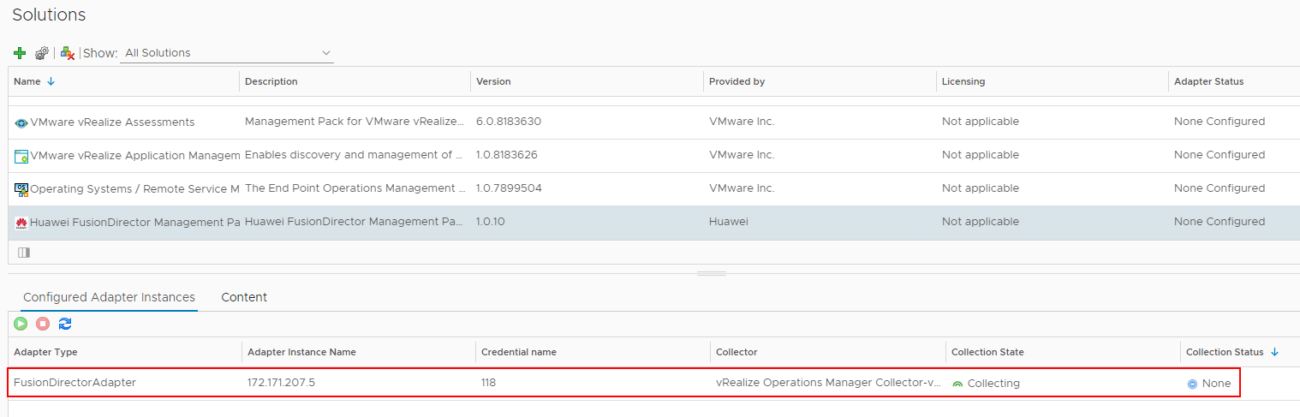

----End

Modification
            - On the vROps WebUI, choose Administration.
The Administration page is displayed.
            - In the navigation pane, choose Solutions.
The Solutions page is displayed.
            - Select the vROps plug-in and click .
The Manage Solution - Huawei FusionDirector Management Pack dialog box is displayed.
            - In the navigation pane, select a FusionDirector instance to be modified and set the following parameters, as shown in Figure 1-1.
              - Modifying the FusionDirector instance
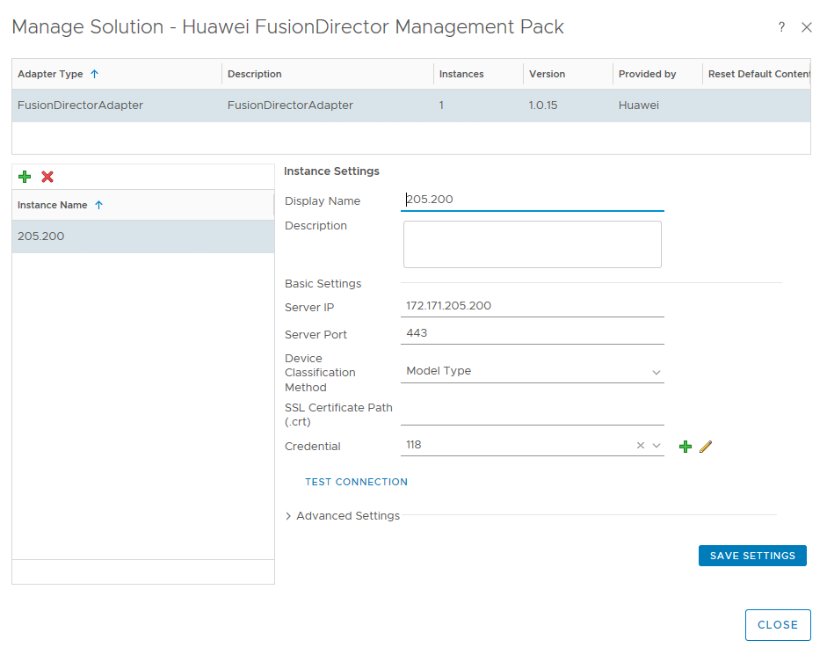

- Display name: user-defined name to identify different FusionDirector instances
- Description: (optional) user-defined description to describe a FusionDirector instance
- Server IP: FusionDirector IP address
- Server Port: FusionDirector port number, which is 443 by default.
- Device Classification Method: way to classify servers
- Model Type: classify servers by type
- Group Type: classify servers by group
- SSL Certificate Path(.crt): (optional) path of the certificate in the vROps
- Credential: Click to change the credential name, username, and password.
If the FusionDirector port number, username, or password is changed after the FusionDirector connection, you need to synchronize the new port number, user name, or password to the FusionDirector. Otherwise, server management is affected.
            - Check whether basic settings of the instance are modified.
- Click TEST CONNECTION. After test connection is successful, click SAVE SETTINGS.
- If failed, click SAVE SETTINGS.
The dialog box is displayed indicating that the settings are successfully saved, as shown in Figure 1-1.
              - Successfully saving settings

            - Click OK.
The FusionDirector instance is modified.
            - Click CLOSE.
On the Solutions page, view the data collected by the FusionDirector instance after modification, as shown in Figure 1-1.
              - Collecting data
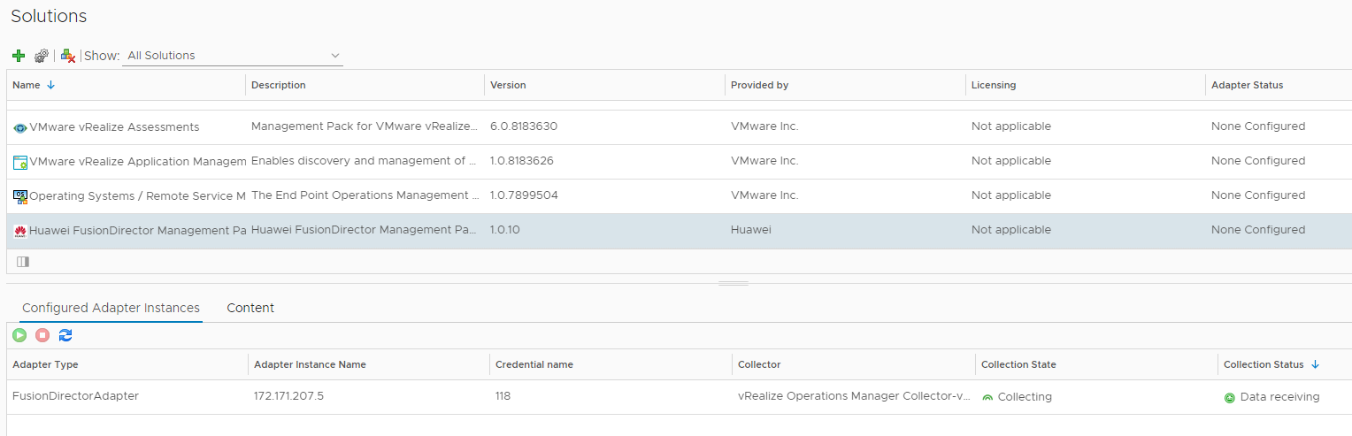

----End

Deletion
            - On the vROps WebUI, choose Administration.
The Administration page is displayed.
            - In the navigation pane, choose Solutions.
The Solutions page is displayed.
            - Select the vROps plug-in and click .
The Manage Solution - Huawei FusionDirector Management Pack dialog box is displayed.
            - In the navigation pane, select the FusionDirector instance to be deleted and click , as shown in Figure 1-1.
              - Managing solutions
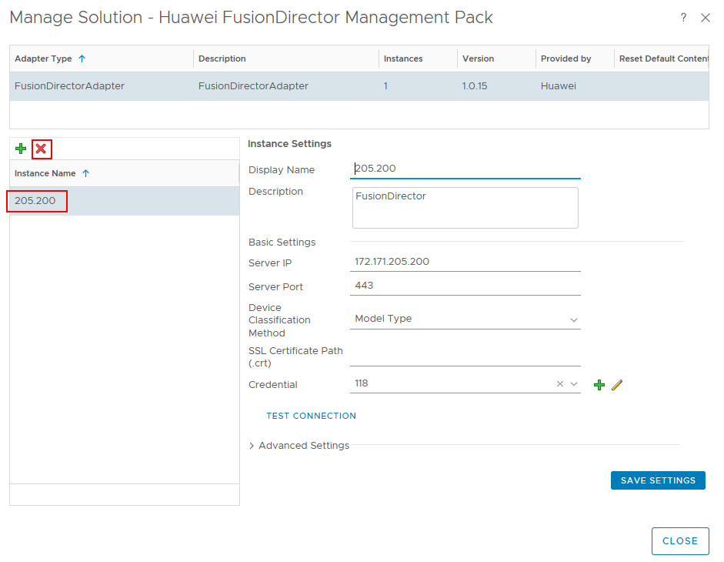

The Confirmation dialog box is displayed.
            - Select Remove related objects. (which is selected by default) and click YES.
The FusionDirector instance is deleted.
----End

Querying Server Information
4.1 Querying Servers
4.2 Querying Component Information
4.3 Querying Component Group Information
4.4 Querying Server Information
4.5 Querying Server Type Information
4.6 Querying the FusionDirector Information

Querying Servers
            - On the vROps WebUI, choose Environment.
The Environment page is displayed.
            - In the navigation pane, choose Huawei FusionDirector Management Pack > Huawei Servers.
The Huawei Servers page is displayed.
            - In the navigation pane, view the list of all servers, as shown in Figure 1-1 and Figure 1-2.
              - Huawei servers by Model Type
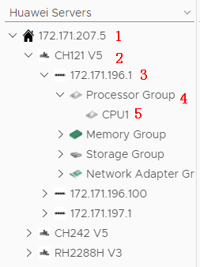

- 1: FusionDirector IP address
- 2: Server model
- 3: Server label and BMC IP address. If no label is set for the server, only the BMC IP address is displayed. For details about how to set the server label, see FusionDirector User Guide.
- 4: Component group
- 5: A component
              - Huawei servers by Group Type
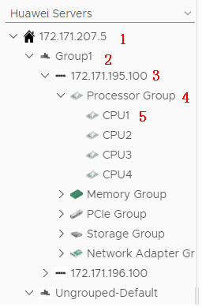

- 1: FusionDirector IP address
- 2: Server group name, which can be set in the FusionDirector. For details, see FusionDirector User Guide.
- 3: Server label and BMC IP address. If no label is set for the server, only the BMC IP address is displayed. For details about how to set the server label, see FusionDirector User Guide.
- 4: Component type
- 5: A component
----End

Querying Component Information
            - On the vROps WebUI, select Environment.
The Environment page is displayed.
            - In the navigation pane, choose Huawei FusionDirector Management Pack > Huawei Servers.
The Huawei Servers page is displayed.
            - Select a FusionDirector IP address, a server model (by Group Type), a server, a component group, and a component, as shown in Figure 1-1.
              - Component information
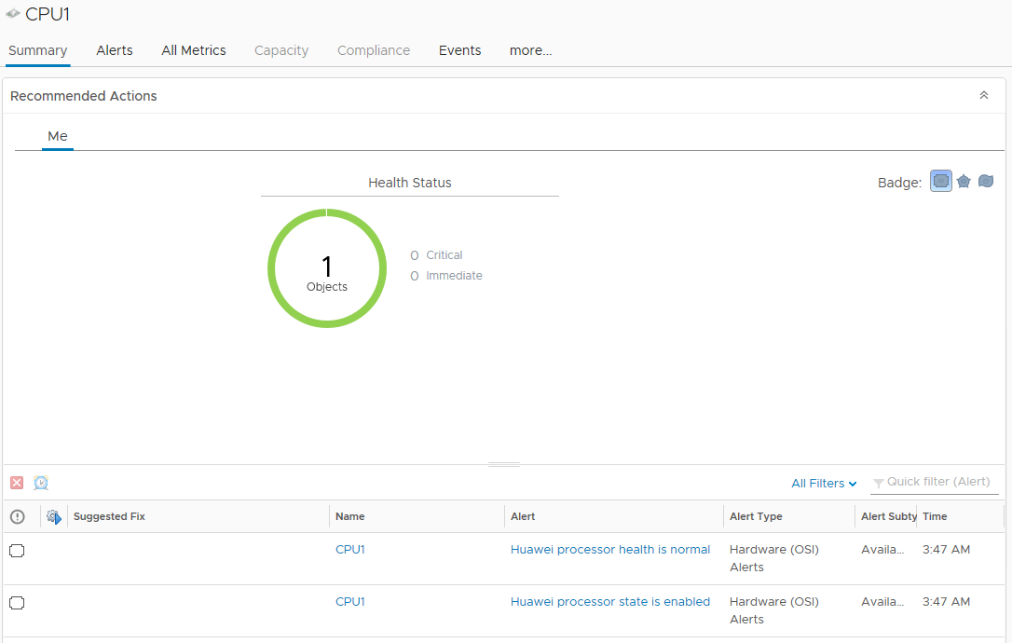

            - Click Summary.
The Summary page is displayed. View the running status of the component in the Recommended Actions area, as shown in Figure 1-1.
              - Summary

            - Click the Alerts tab.
On the Alerts tab page, click an alert to view its details, as shown in Figure 1-1.
              - Alerts
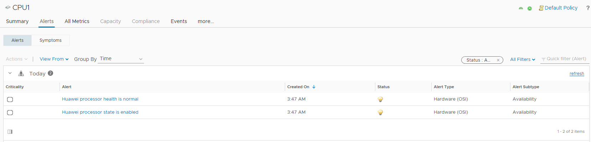

            - Click more > Details.
On the Details tab page, select a view to view its details, as shown in Figure 1-1.
              - Details
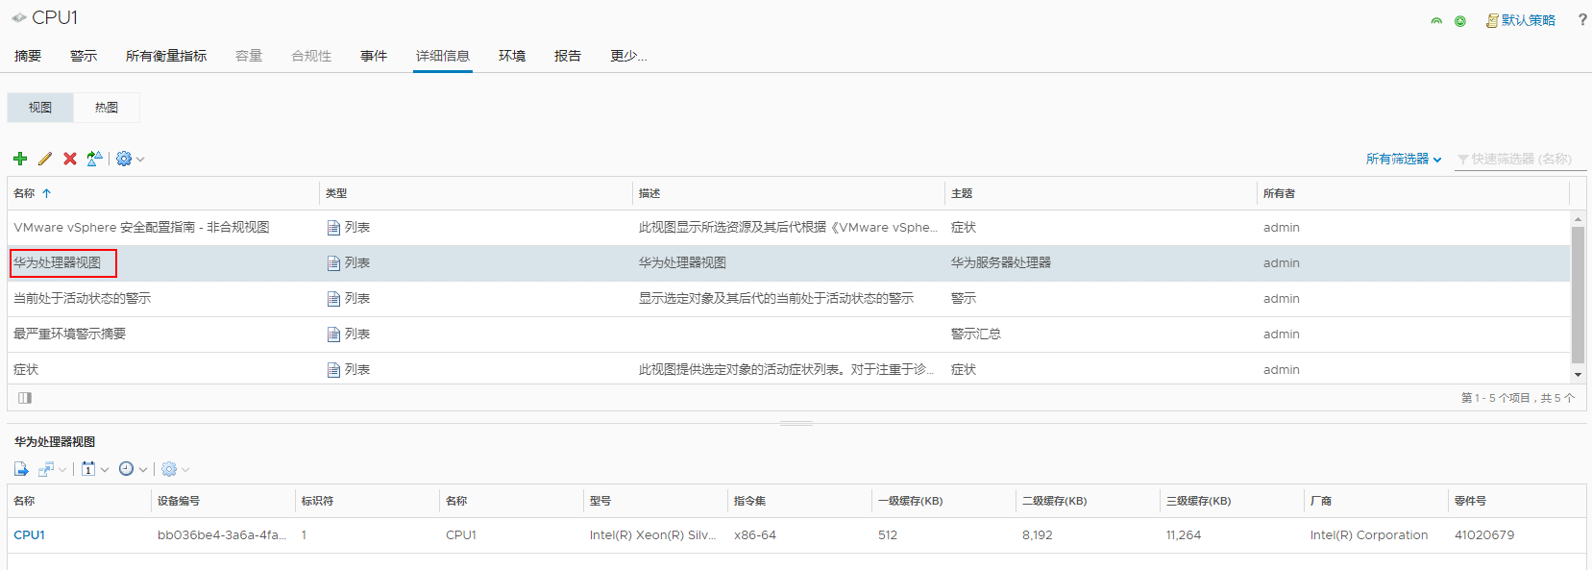

----End

Querying Component Group Information
            - On the vROps WebUI, choose Environment.
The Environment page is displayed.
            - In the navigation pane, choose Huawei FusionDirector Management Pack > Huawei Servers.
The Huawei Servers page is displayed.
            - Select a FusionDirector IP address, a server model (by Group Type), a server, and a component group, as shown in Figure 1-1.
See 4.2 Querying Component Information to view the summary, alerts, and details of all components in the component group.
              - Component group information
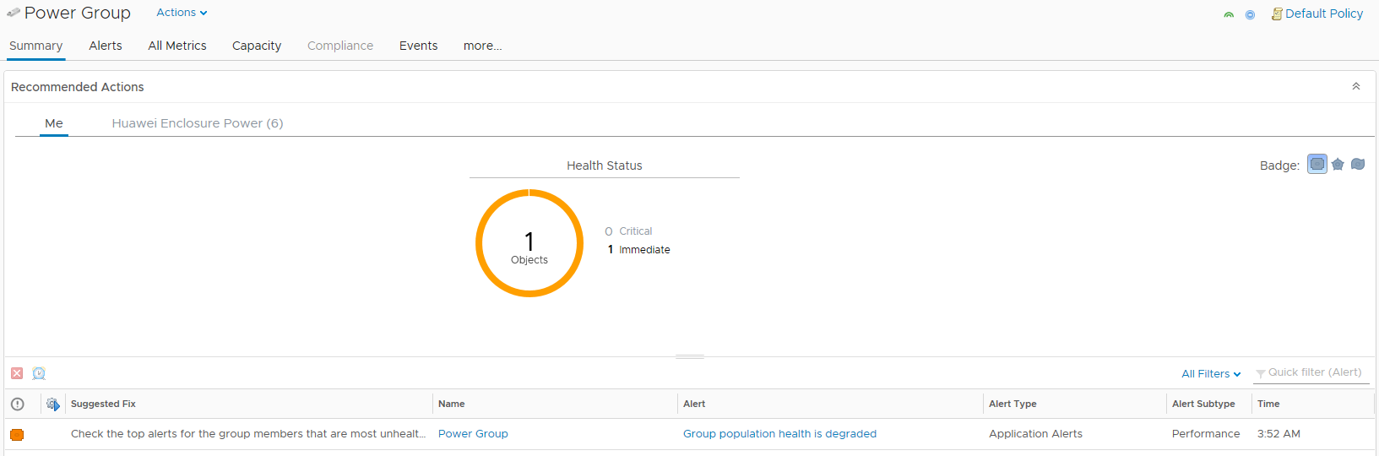

----End

Querying Server Information
            - On the vROps WebUI, choose Environment.
The Environment page is displayed.
            - In the navigation pane, choose Huawei FusionDirector Management Pack > Huawei Servers.
The Huawei Servers page is displayed.
            - Select a FusionDirector IP address, a server model (by Group Type), and a server, as shown in Figure 1-1.
See 4.2 Querying Component Information to view the summary, alerts, and details of all components on a server.
              - Server information
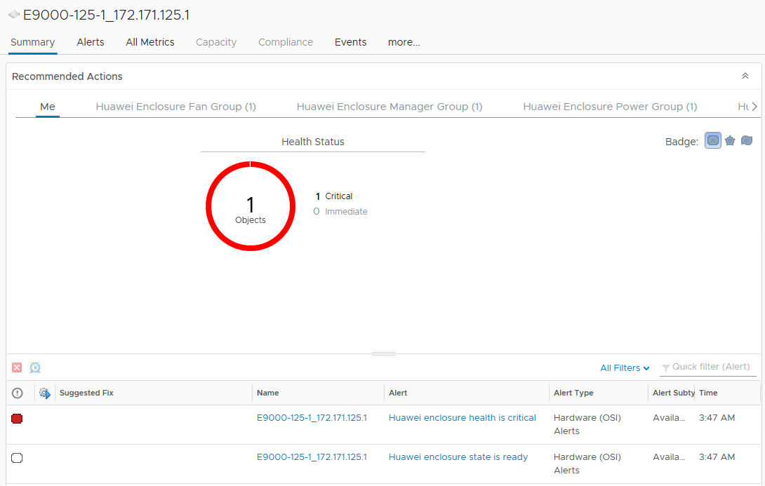

----End

Querying Server Type Information
            - On the vROps WebUI, choose Environment.
The Environment page is displayed.
            - In the navigation pane, choose Huawei FusionDirector Management Pack > Huawei Servers.
The Huawei Servers page is displayed.
            - Select a FusionDirector IP address and a server model (by Group Type), as shown in Figure 1-1.
See 4.2 Querying Component Information to view the summary, alerts, and details of all components of one server type.
              - Server type
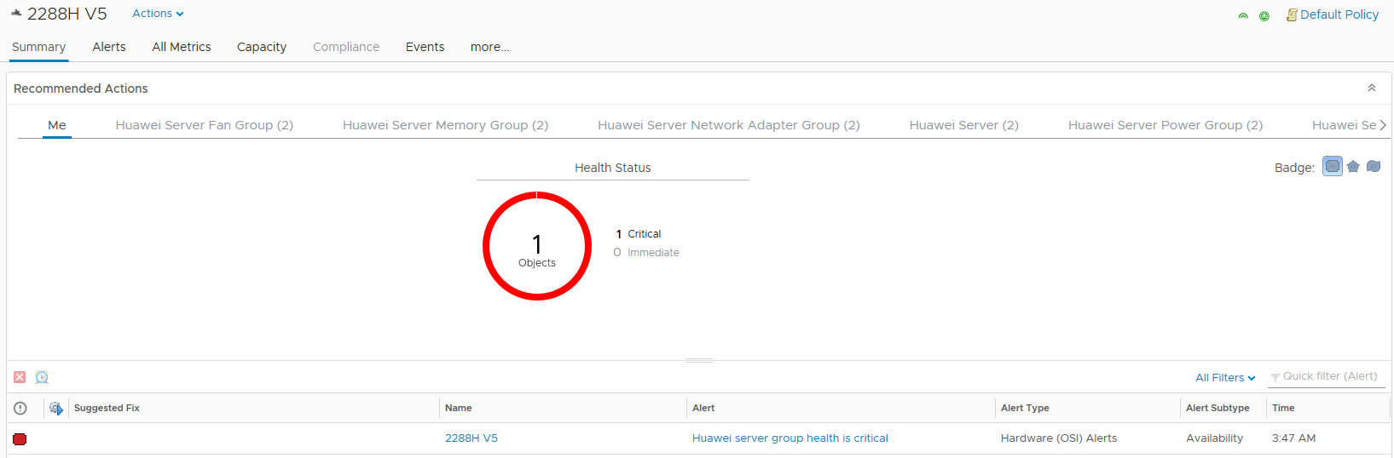

----End

Querying the FusionDirector Information
            - On the vROps WebUI, choose Environment.
The Environment page is displayed.
            - In the navigation pane, choose Huawei FusionDirector Management Pack > Huawei Servers.
The Huawei Servers page is displayed.
            - Select a FusionDirector IP address, as shown in Figure 1-1.
See 4.2 Querying Component Information to view the summary, alerts, and details of all components in the FusionDirector.
              - FusionDirector information
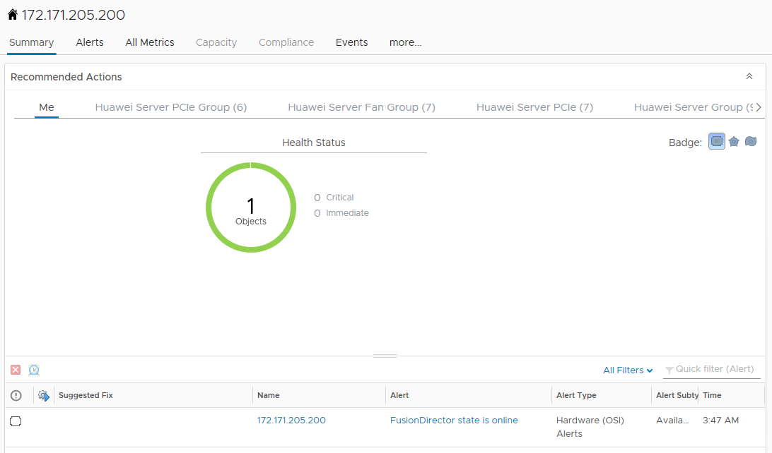

----End

Querying Enclosure Information
5.1 Querying Enclosures
5.2 Querying Component Information
5.3 Querying Component Group Information
5.4 Querying Enclosure Information
5.5 Querying the FusionDirector Information

Querying Enclosures
            - On the vROps WebUI, choose Environment.
The Environment page is displayed.
            - In the navigation pane, choose Huawei FusionDirector Management Pack > Huawei Enclosures.
The Huawei Enclosures page is displayed.
            - In the navigation pane, view the list of all enclosures, as shown in Figure 1-1.
              - Huawei enclosures
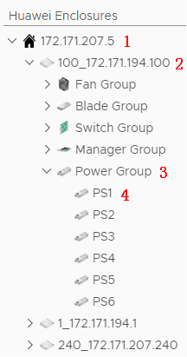

- 1: FusionDirector IP address
- 2: Enclosure name and BMC IP address
- 3: Component group
- 4: A component
----End

Querying Component Information
            - On the vROps WebUI, choose Environment.
The Environment page is displayed.
            - In the navigation pane, choose Huawei FusionDirector Management Pack > Huawei Enclosures.
The Huawei Enclosures page is displayed.
            - Select a FusionDirector IP address, an enclosure, a component group, and a component, as shown in Figure 1-1.
              - Component information
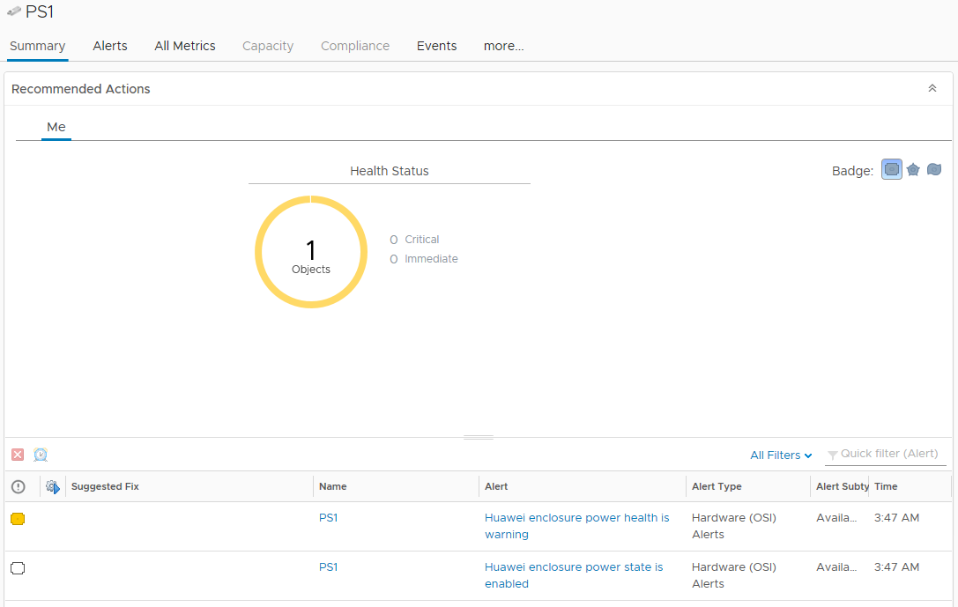

            - Click Summary.
The Summary page is displayed. View the running status of the component in the Recommended Actions area, as shown in Figure 1-1.
              - Summary

            - Click the Alerts tab.
On the Alerts tab page, click an alert to view its details, as shown in Figure 1-1.
              - Alerts
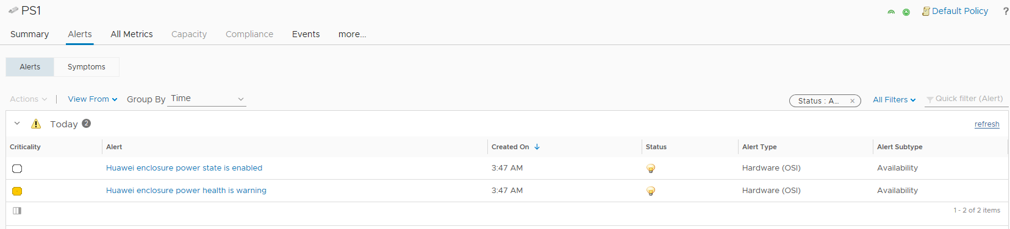

            - Click more > Details.
On the Details tab page, select a view to view its details, as shown in Figure 1-1.
              - Details
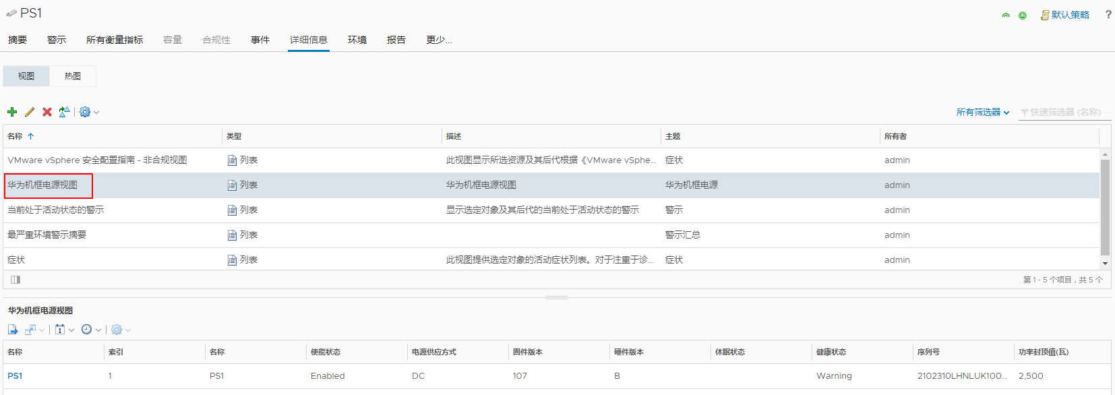

----End

Querying Component Group Information
            - On the vROps WebUI, choose Environment.
The Environment page is displayed.
            - In the navigation pane, choose Huawei FusionDirector Management Pack > Huawei Enclosures.
The Huawei Enclosures page is displayed.
            - Select a FusionDirector IP address, an enclosure, and a component group, as shown in Figure 1-1.
See 5.2 Querying Component Information to view the summary, alerts, and details of all components in the component group.
              - Component information

----End

Querying Enclosure Information
            - On the vROps WebUI, choose Environment.
The Environment page is displayed.
            - In the navigation pane, choose Huawei FusionDirector Management Pack > Huawei Enclosures.
The Huawei Enclosures page is displayed.
            - Select a FusionDirector IP address and an enclosure, as shown in Figure 1-1.
See 5.2 Querying Component Information to view the summary, alerts, and details of all components using the enclosure.
              - Enclosure information

----End

Querying the FusionDirector Information
            - On the vROps WebUI, choose Environment.
The Environment page is displayed.
            - In the navigation pane, choose Huawei FusionDirector Management Pack > Huawei Enclosures.
The Huawei Enclosures page is displayed.
            - Select a FusionDirector IP address, as shown in Figure 1-1.
See 5.2 Querying Component Information to view the summary, alerts, and details of all components in the FusionDirector.
              - FusionDirector information
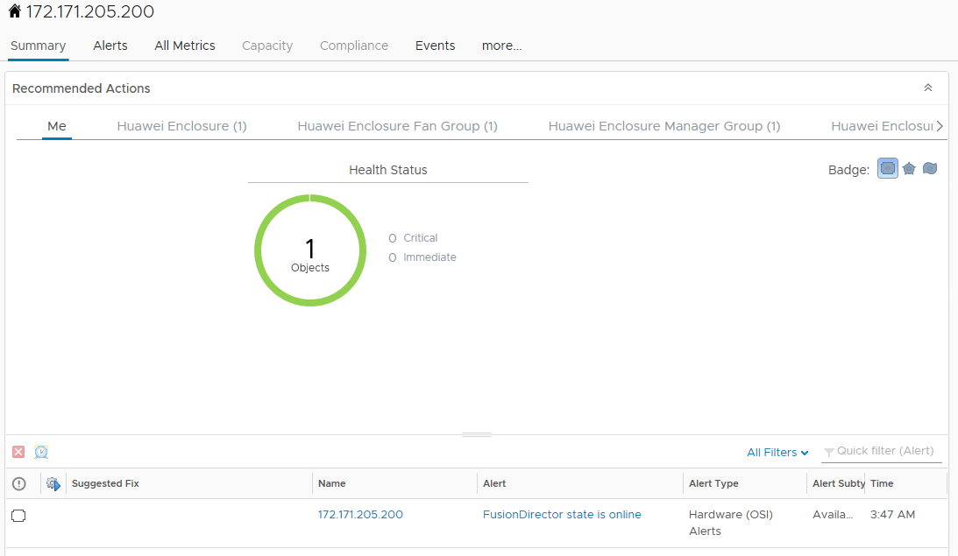

----End

Querying Dashboard Information
6.1 Querying the FusionDirector Overview Dashboard
6.2 Querying Huawei Servers Overview Dashboard
6.3 Querying Huawei Server Detailed Dashboard
6.4 Querying Huawei Enclosure Overview Dashboard
6.5 Querying Huawei Enclosure Detailed Dashboard

Querying the FusionDirector Overview Dashboard
            - On the vROps WebUI, choose Dashboards.
The Dashboards page is displayed.
            - In the navigation pane, choose Dashboards > Fusion Director Overview Dashboard.
The Fusion Director Overview Dashboard page is displayed.
You can view the FusionDirector name, adapter type, object type, policy, collection state, collection status, server IP address, port, state, FusionDirector version, and classification method, as shown in Figure 1-1.
              - FusionDirector Overview Dashboard
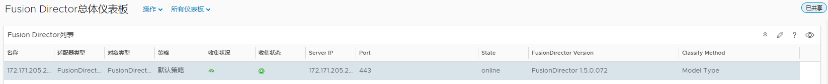

----End

Querying Huawei Servers Overview Dashboard
            - On the vROps WebUI, choose Dashboards.
The Dashboards page is displayed.
            - In the navigation pane, choose Dashboards > Huawei Servers Overview Dashboard.
The Huawei Servers Overview Dashboard page is displayed.
You can view the following information, as shown in Figure 1-1.
- Servers Environment Health
- Servers Latest Alerts
- Top High Power Consumption Servers
- Top High Inlet Temperature Servers
- Top High Fan Speed On Average Servers
- Select About for Power Consumption Trend
- Select About for Temperature Trend
- Select About for Fan Speed Trend
              - Huawei Servers Overview Dashboard
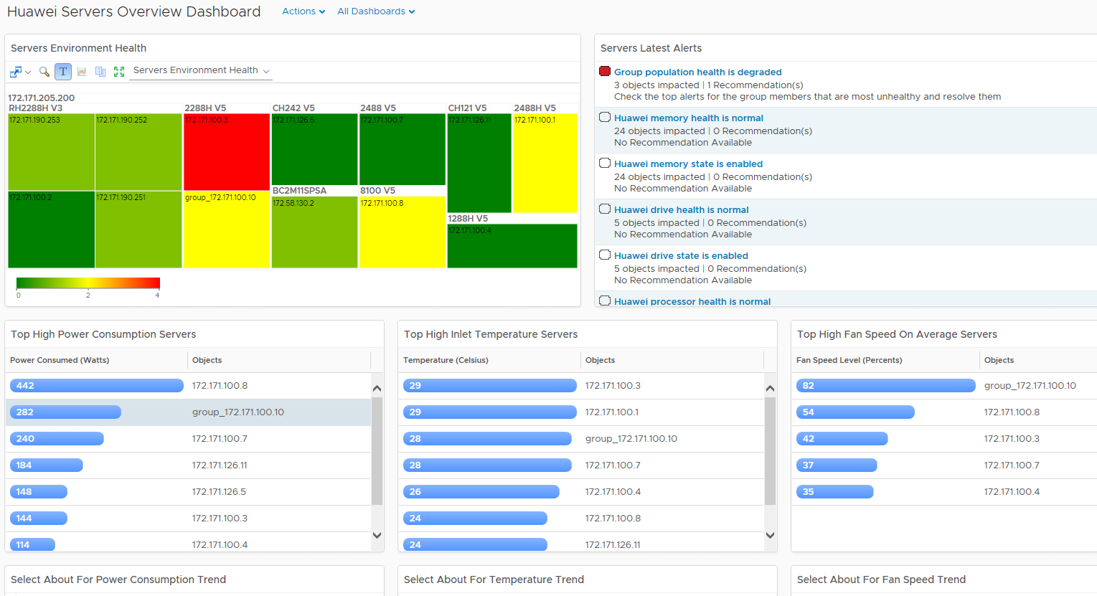

            - In the Servers Environment Heath area, select a server. You can view the latest alarms of the server in the Servers Latest Alerts area, as shown in Figure 1-1.
              - Huawei Servers Latest Alerts
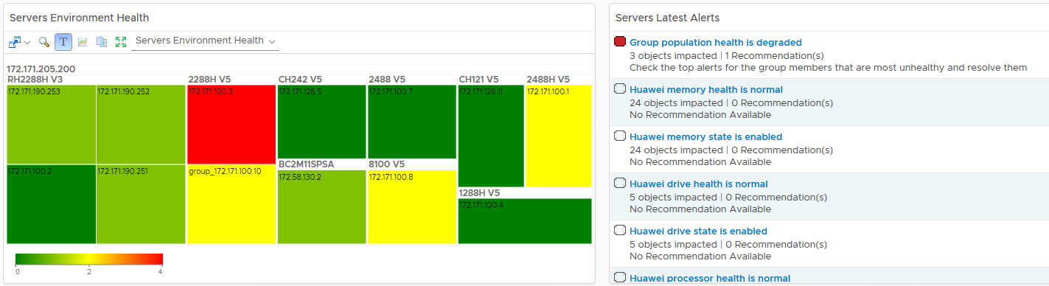

            - In the Top High Power Consumption Servers area, select different servers. You can view power consumption trends of these servers in the Select About For Power Consumption Trend area, as shown in Figure 1-1.
              - Power consumption trend
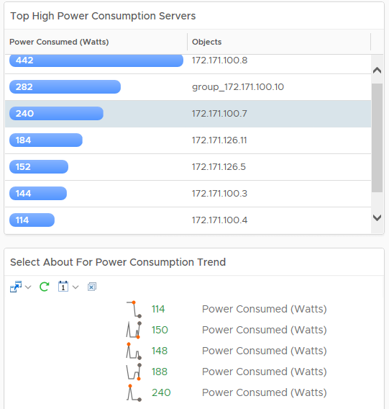

            - In the Top High Inlet Temperature Servers area, select different servers. You can view temperature trends of these servers in the Select About For Temperature Trend area, as shown in Figure 1-1.
              - Temperature trend
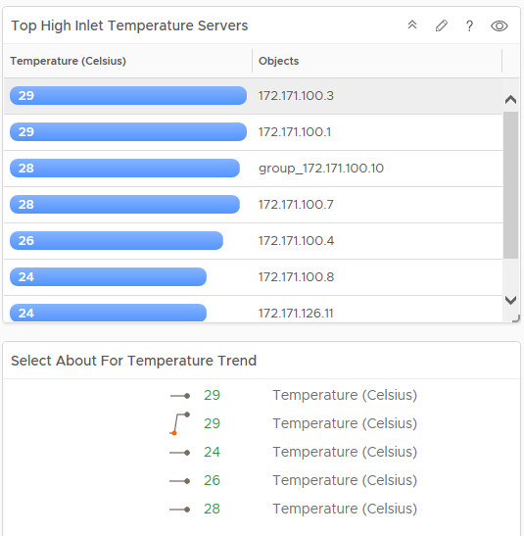

            - In the Top High Fan Speed On Average Servers area, select different servers. You can view fan speed trends of these servers in the Select About For Fan Speed Trend area, as shown in Figure 1-1.
              - Fan speed trend
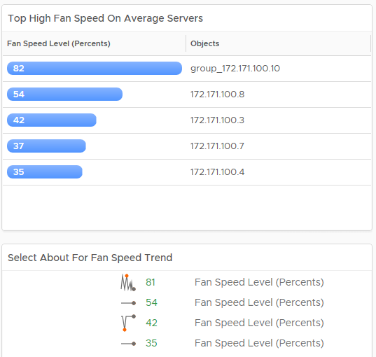

----End

Querying Huawei Server Detailed Dashboard
            - On the vROps WebUI, choose Dashboards.
The Dashboards page is displayed.
            - In the navigation pane, choose Dashboards > Huawei Server Detailed Dashboard.
The Huawei Server Detailed Dashboard page is displayed.
            - In the Huawei Server List area, select the server to be viewed.
You can view the following information, as shown in Figure 1-1.
- Object Relationship
- Latest Alerts
- Huawei Server Power Consumption Metric Chart
              - Huawei Server Detailed Dashboard
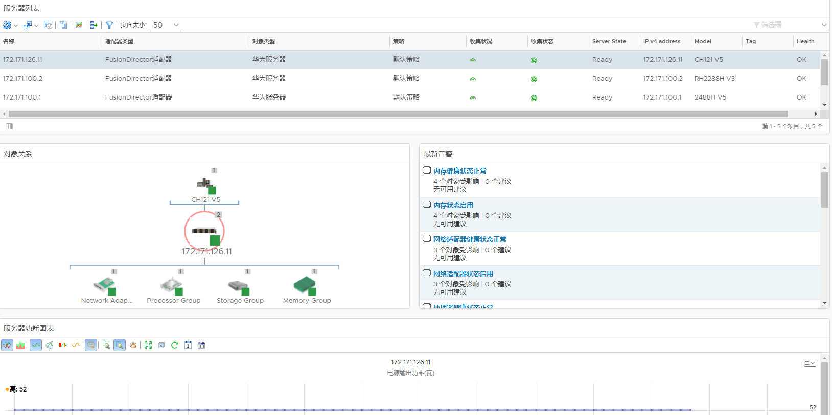

            - The server topology is displayed in the Object Relationship area. You can click any server to view the alerts and detailed information about the server, as shown in Figure 1-1.
              - Object Relationship
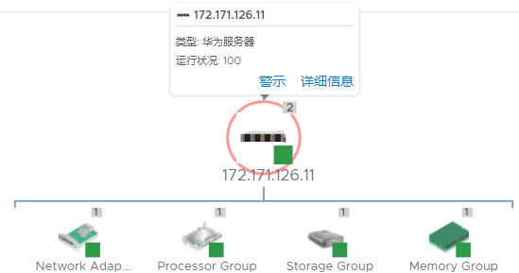

----End

Querying Huawei Enclosure Overview Dashboard
            - On the vROps WebUI, choose Dashboards.
The Dashboards page is displayed.
            - In the navigation pane, choose Dashboards > Huawei Enclosure Overview Dashboard.
The Huawei Enclosure Overview Dashboard page is displayed.
You can view the following information, as shown in Figure 1-1.
- Enclosure Environment Health
- Enclosure Latest Alerts
              - Huawei Enclosure Overview Dashboard
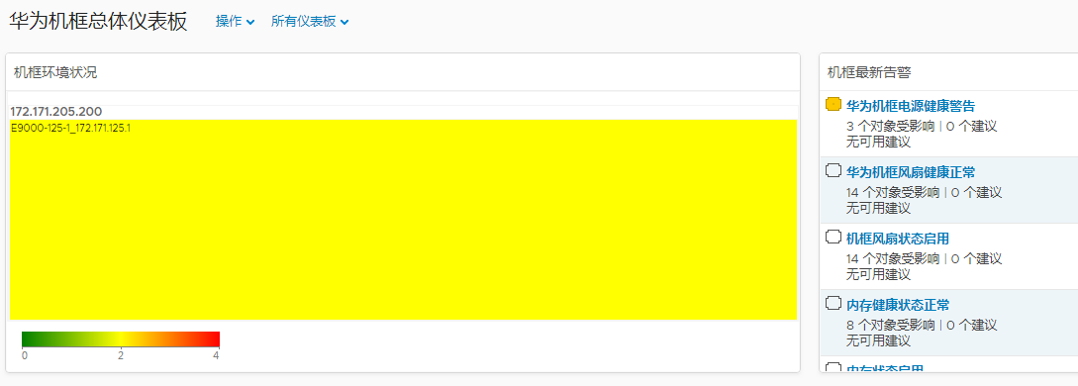

----End

Querying Huawei Enclosure Detailed Dashboard
            - On the vROps WebUI, choose Dashboards.
The Dashboards page is displayed.
            - In the navigation pane, choose Dashboards > Huawei Enclosure Detailed Dashboard.
The Huawei Enclosure Detailed Dashboard page is displayed.
            - In the Enclosure List area, select the enclosure to be viewed.
You can view the following information, as shown in Figure 1-1.
- Latest Alerts
- Object Relationship
              - Huawei Enclosure Detailed Dashboard
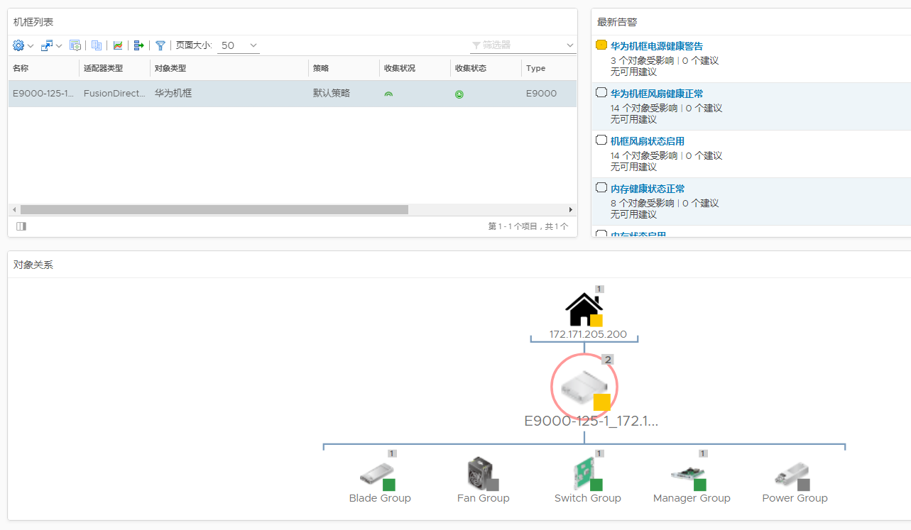

            - The enclosure topology is displayed in the Object Relationship area. You can click any enclosure or component to view the alerts and detailed information, as shown in Figure 1-1.
              - Object Relationship
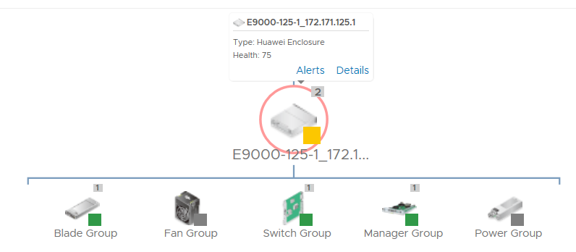

----End

Viewing Alerts
            - On the vROps WebUI, choose Alerts.
The Alerts page is displayed.
            - In the navigation pane, choose All Alerts.
The All Alerts dialog box is displayed.
            - Select Object Type from the Group By drop-down list box.
            - In an alert row, click Triggered On, as shown in Figure 1-1.

You can only select a component, not a component group. Otherwise, the alerted server cannot be located.
              - All alerts
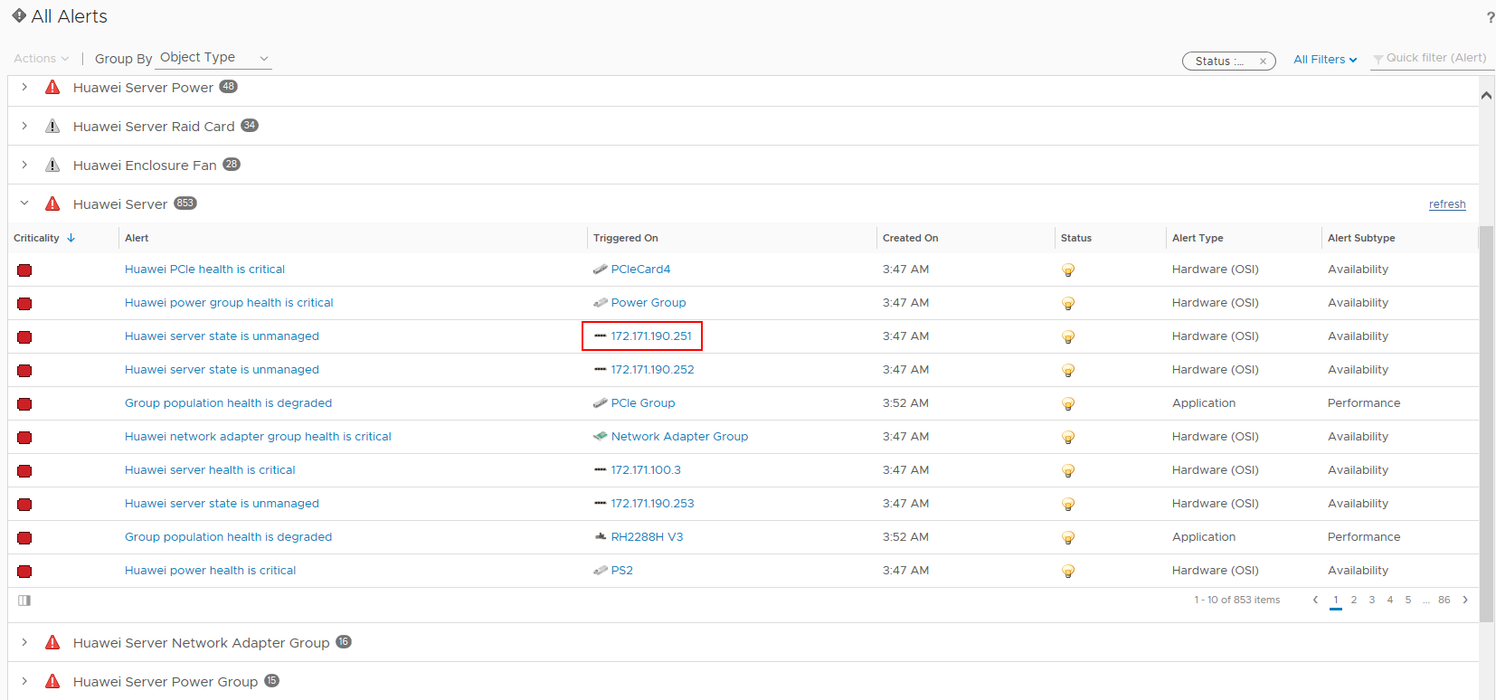

The page about the triggered object is displayed, as shown in Figure 1-2.
              - Triggered object
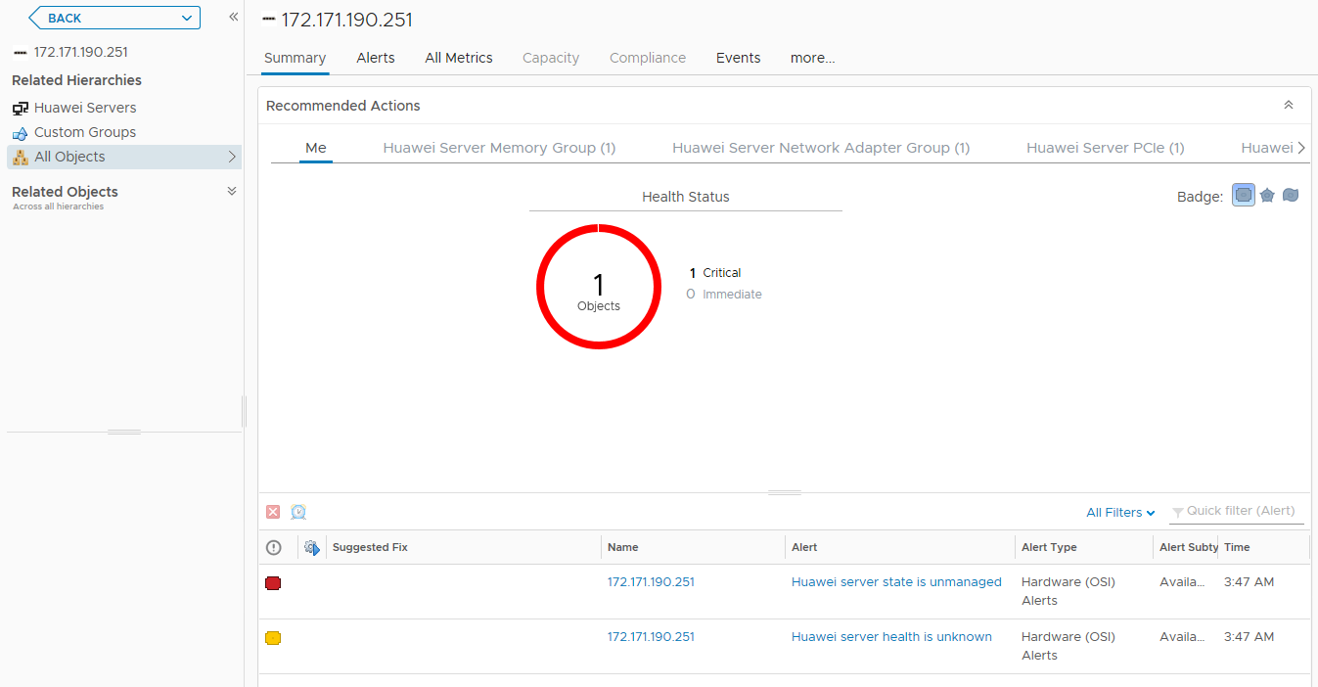

            - In the navigation pane, choose All Objects.
The All Objects page is displayed, as shown in Figure 1-1.
              - All objects
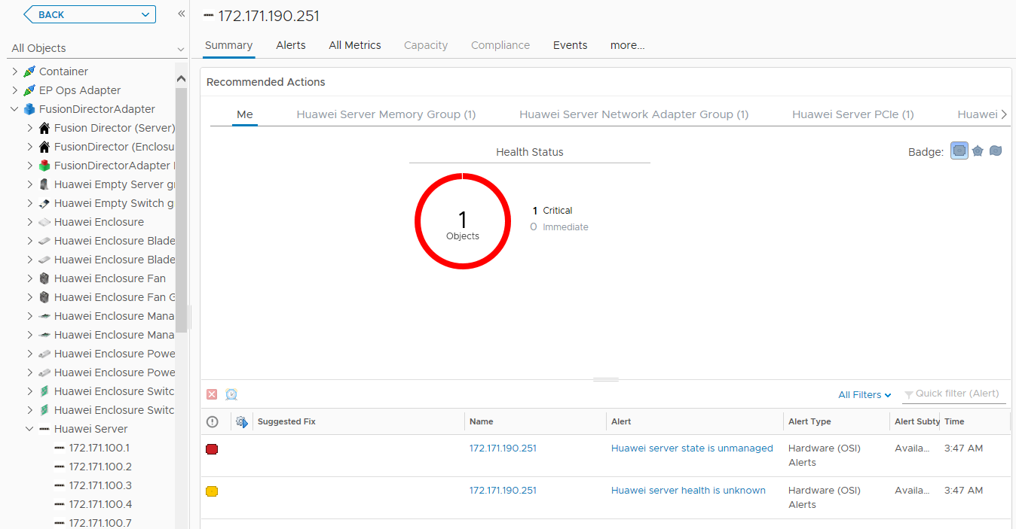
----End

Querying the Huawei vROps Plug-in Version
            - On the vROps WebUI, choose Administration.
The Administration page is displayed.
            - In the navigation pane, choose Solutions.
The Solutions page is displayed.
            - Check the current version of the Huawei vROps plug-in, as shown in Figure 1-1.
              - Solutions
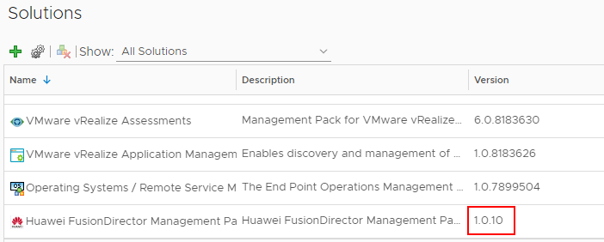

----End

